**OPTIMIZING USER, GROUP, AND ROLE MANAGEMENT WITH ACCESS CONTROL AND WORKFLOWS**

**PROBLEM STATEMENT**

The existing setup does not clearly define user roles, manage access levels, or follow a structured workflow. Because of this, task allocation and progress tracking become unclear, which causes delays and confusion during the project lifecycle.

**OBJECTIVE**

* Establish a structured project management process in **ServiceNow**.
* Define and assign **user roles** for clear responsibilities.
* Create and manage **groups** for streamlined collaboration.
* Configure **table access** and implement proper **security controls**.
* Build **workflows** to automate task assignment and progress tracking.
* Improve **accountability**, **communication**, and **project visibility** across the team.

**SKILLS**

* **ServiceNow Administration** – User, group, and role management
* **Access Control (ACL)** – Configuring secure table and field-level permissions
* **Table & Module Configuration** – Creating and customizing tables, applications, and modules
* **Workflow & Flow Designer** – Automating task assignment and approvals
* **Role-Based Access Management** – Assigning table roles and application access
* **Project Management Basics** – Organizing tasks, tracking progress, and ensuring accountability

**TASK INITIATION**

**Milestone 1 : Users**

**Activity 1:** **Create Users**

**Steps to Create Users in ServiceNow**

1. Open **ServiceNow**.
2. From the left-hand navigation menu, click **All** and search for **Users**.
3. Under **System Security**, select **Users**.
4. Click **New** to create a user record.
5. Enter the required user details in the form and click **Submit**.
6. Repeat steps 4–5 to create additional users as needed, filling in the appropriate details for each one. U could see fig 1 and fig 2 for the details I filled.

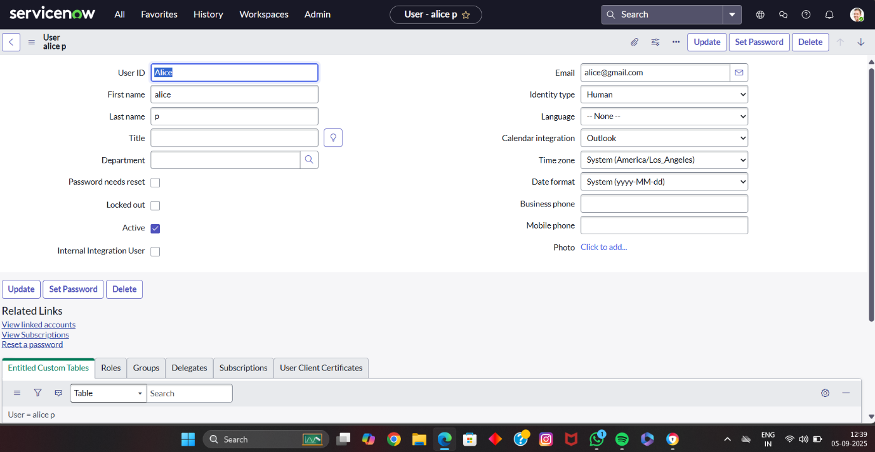

**Fig1:user alice**

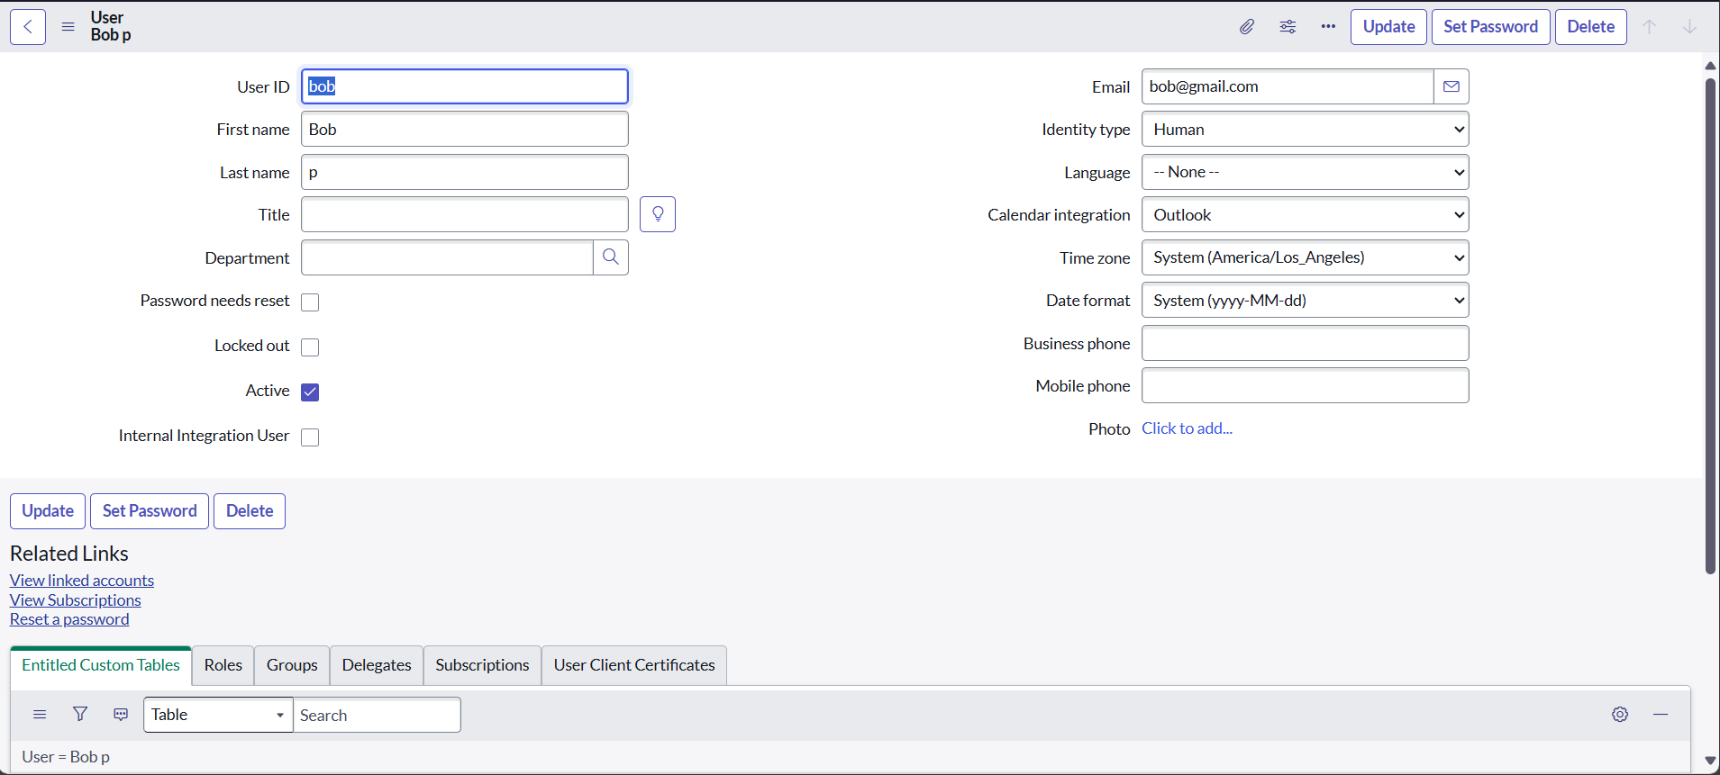

**Fig 2:User Bob**

**Milestone 2 : Groups**

**Activity 1:** **Create Groups**

**Steps to Create Groups in ServiceNow**

1. Open **ServiceNow**.
2. In the left navigation menu, click **All** and search for **Groups**.
3. Under **System Security**, select **Groups**.
4. Click **New** to add a new group.
5. Enter the required group details in the form.
6. Click **Submit** to save the group.

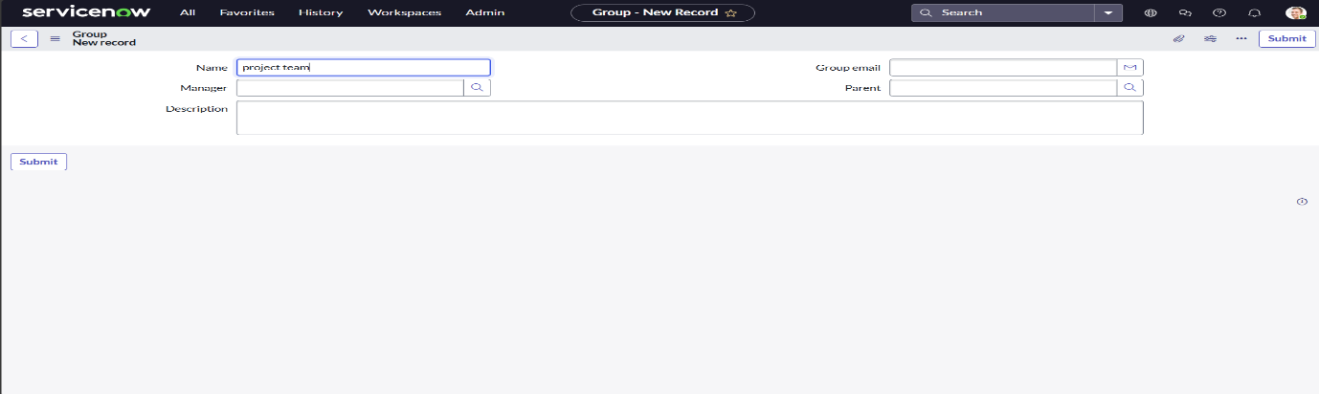**Fig 3: Creating a new group**

**Milestone 3 : Roles**  
**Activity 1:** **Create roles**

**Steps to Create Roles in ServiceNow**

1. Open **ServiceNow**.
2. In the left navigation menu, click **All** and search for **Roles**.
3. Under **System Security**, select **Roles**.
4. Click **New** to create a role.
5. Enter the required role details in the form.
6. Click **Submit** to save the role.
7. To create another role (e.g., **Team Member**), repeat steps 4–6 with the new details.

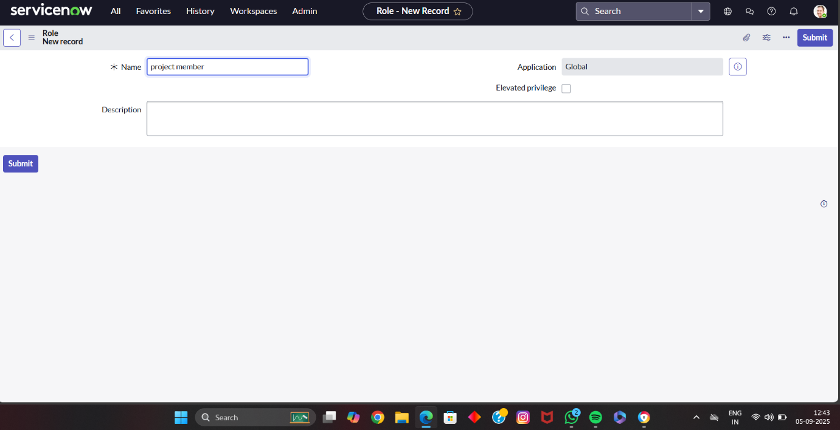

**Fig 4:Creating Roles**

**Milestone 4 : Table**

**Activity 1:** **Create Table**

**Steps to Create Tables in ServiceNow**

1. Open **ServiceNow**.
2. From the left navigation menu, click **All** and search for **Tables**.
3. Under **System Definition**, select **Tables**.
4. Click **New** to create a table.
5. Fill in the following details:
   * **Label:** Project Table
   * Enable the checkboxes **Create Module** and **Create Mobile Module**
   * **New Menu Name:** Project Table
6. Add the required **Table Columns**.
7. Click **Submit** to save the table.
8. To create another table, repeat steps 4–7 using the details for **Task Table**
9. Click **Submit** to save the new table.

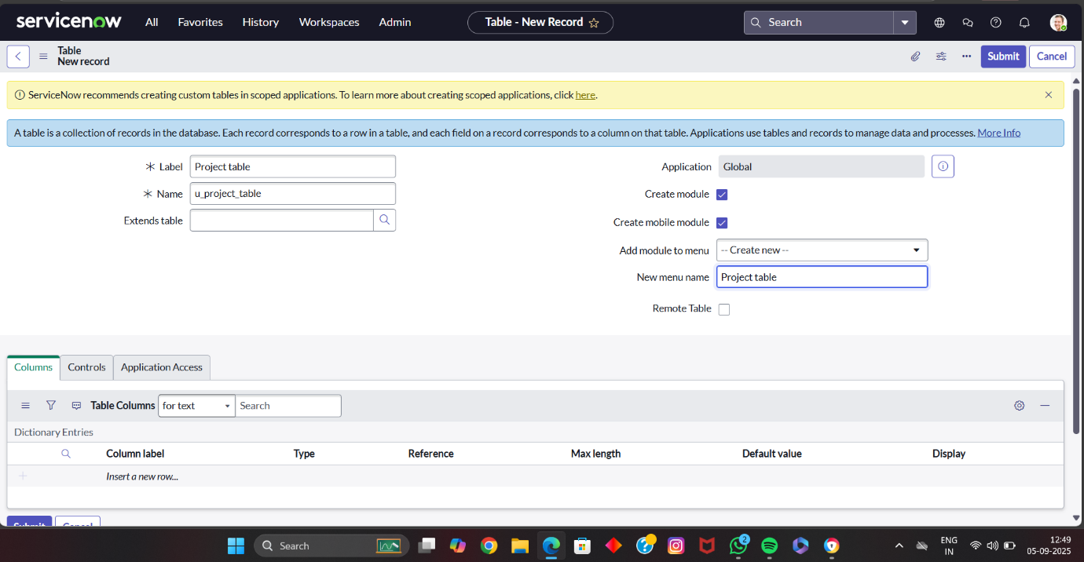

**Fig 5:Table Creation**

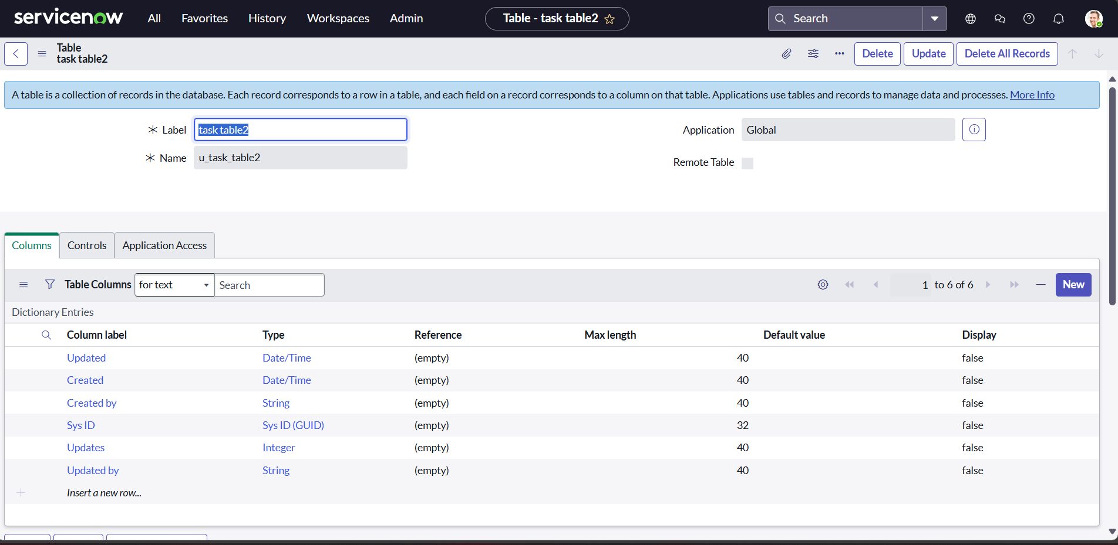

**Fig 6:Task Table2**

**Milestone 5 : Assign  users to groups**

**Activity 1:** **Assign users to project team group**

**Steps to Assign Users to the Project Team Group in ServiceNow**

1. Open **ServiceNow**.
2. From the left navigation menu, click **All** and search for **Groups**.
3. Under **System Security**, select **Groups**.
4. Locate and open the **Project Team** group.
5. In the **Group Members** section, click **Edit**.
6. Select **Alice P** and **Bob P** from the list of available users.
7. Save the changes to add them to the group.

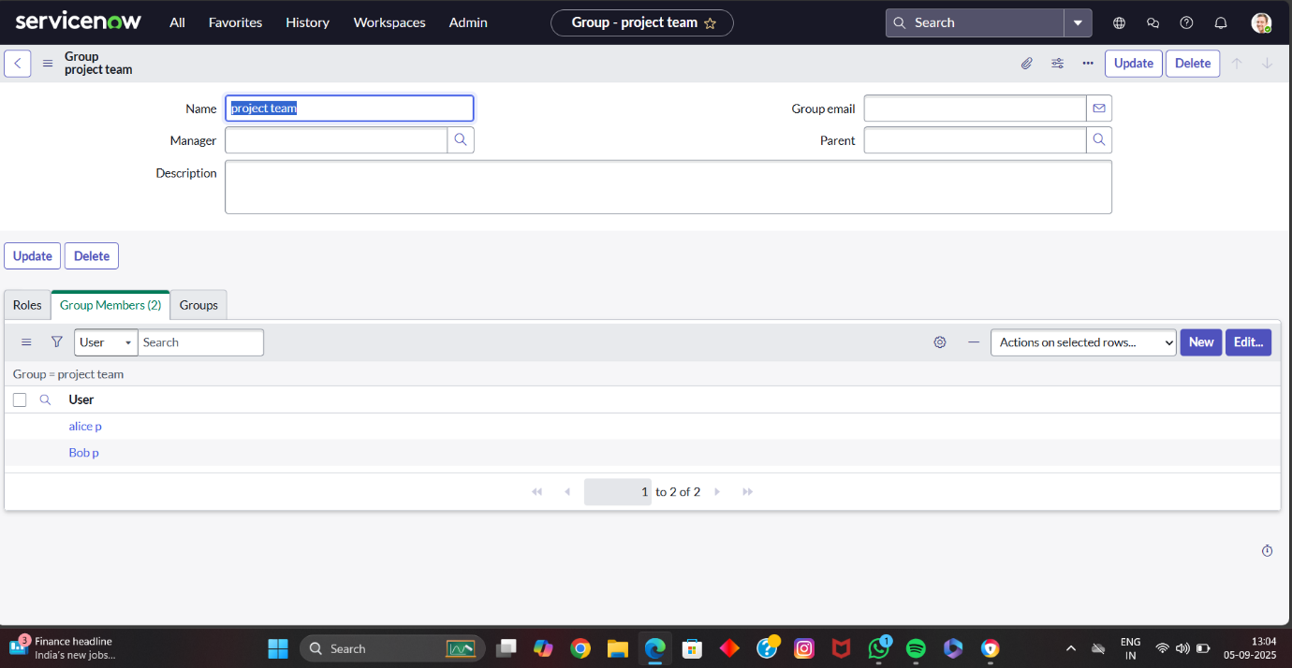

**Fig 7: Assigning users to Team group**

**Milestone 6 : Assign  roles to users**

**Activity 1:** **Assign roles to alice user**

**Steps to Assign Roles to the Alice User in ServiceNow**

1. Open **ServiceNow**.
2. From the left navigation menu, click **All** and search for **Users**.
3. Under **System Security**, select **Users** and open the record for the **Project Manager** user (**Alice**).
4. In the **Roles** section of the user record, click **Edit**.
5. Add the **Project Member** role and click **Save**.
6. Click **Edit** again and add the roles **u_project_table** and **u_task_table**.
7. Click **Save** and **Update** to finalize the changes.

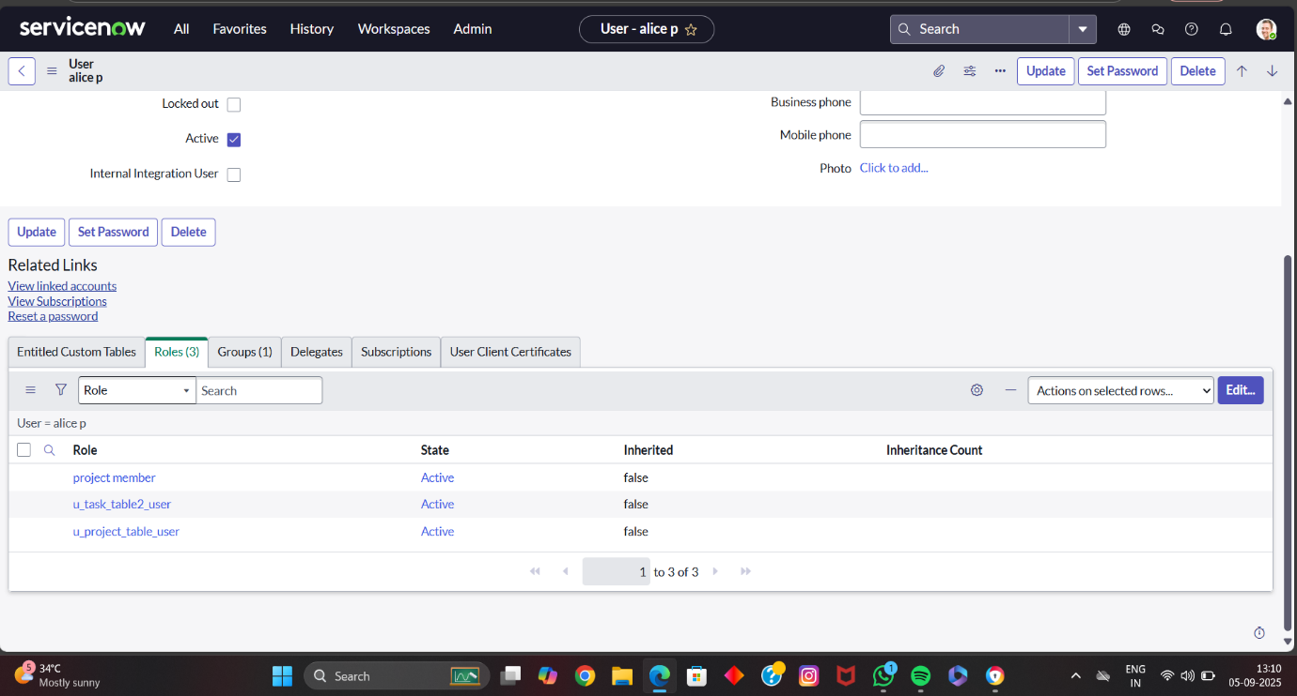

**Fig 8:Assigning Roles to AliceUsers**

**Activity 2:** **Assign roles to bob user**

**Steps to Assign Roles to Bob User in ServiceNow**

1. Open **ServiceNow**.
2. From the left navigation menu, click **All** and search for **Users**.
3. Under **System Security**, select **Users** and open the record for **Bob P**.
4. In the **Roles** section of the user record, click **Edit**.
5. Add the **Team Member** role and the necessary **table roles**, then click **Save**.
6. Click the **Profile** icon and choose **Impersonate User → Bob P**.
7. Verify that **Task Table 2** is visible under Bob’s view.

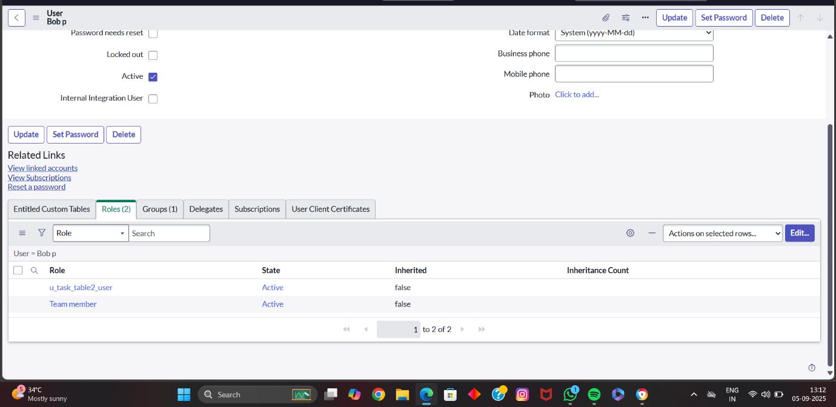

**Fig 9:Assigning Roles to Bob Users**

**Milestone 7 : Application access**

**Activity 1: Assign table access to application**

**Steps to Assign Table Access to an Application in ServiceNow**

1. When you create a table in ServiceNow, an **application** and **module** for that table are automatically created.
2. In the **Application Navigator**, search for the **Project Table** application.
3. Open the module settings and click **Edit**.
4. Assign the **Project Member** role to the Project Table application and save.
5. Next, search for the **Task Table 2** application in the navigator.
6. Open its module or application settings and click **Edit**.
7. Assign the **Project Member** and **Team Member** roles to Task Table 2.
8. Save the changes to update table access.

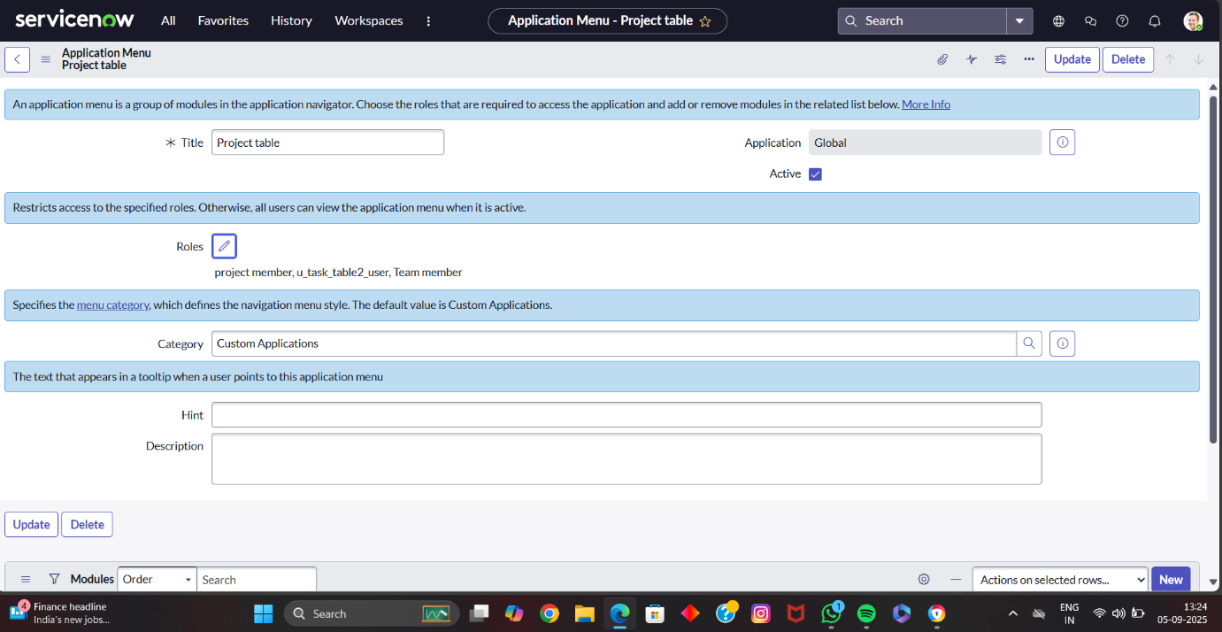

**Fig 10: Assigning table access to application**

**Milestone 8 :Access control list**

**Activity 1: Create ACL**

**Steps to Create Access Controls (ACL) in ServiceNow**

1. Open **ServiceNow**.
2. From the left navigation menu, click **All** and search for **ACL**.
3. Under **System Security**, select **Access Control (ACL)**.
4. Click **Elevate Role** to gain the required permissions.
5. Click **New** to create a new ACL.
6. Fill in the necessary details for the ACL.
7. Scroll down to the **Requires Role** section and double-click to insert a new row.
8. Assign the **Task Table** and **Team Member** role.
9. Click **Submit** to save.
10. Repeat the process to create four ACLs for the required fields (for example, **Comment** and **Status**).
11. Click the profile icon in the top-right corner and choose **Impersonate User**.
12. Select **Bob User**.
13. In the Application Navigator, click **All** and open **Task Table 2** from the application menu.
14. Verify that **Comment** and **Status** fields have edit access for Bob.

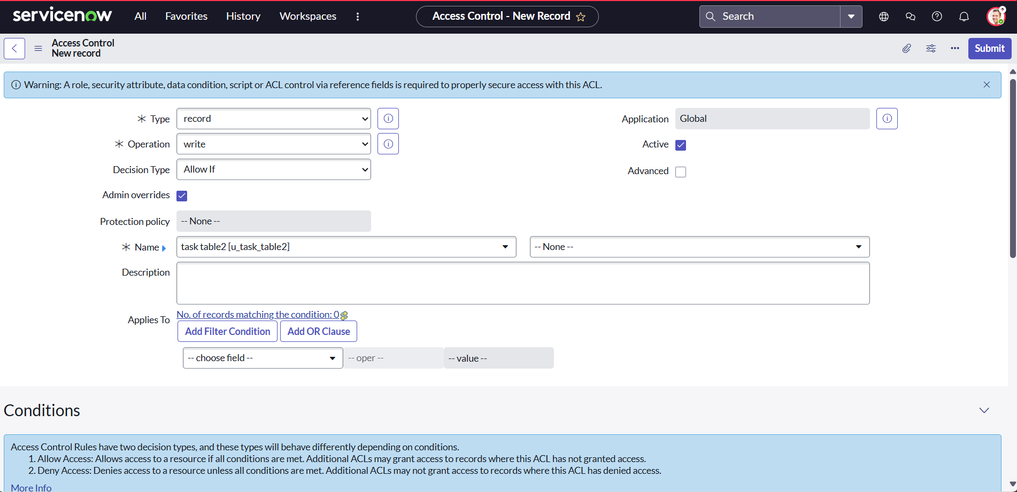

**Fig 11:Creating ACL**

**Milestone 9: Flow**  
    **Activity 1:** **Create a Flow to Assign operations ticket to group**

**Steps to Create a Flow to Assign Operations Tickets to a Group in ServiceNow**

1. Open **ServiceNow**.
2. From the left navigation menu, click **All** and search for **Flow Designer**.
3. Under **Process Automation**, select **Flow Designer**.
4. Click **New** and choose **Flow**.
5. In the **Flow Properties** window:
   * **Flow Name:** Task Table
   * **Application:** Global
6. Click **Build Flow** to start defining the workflow.

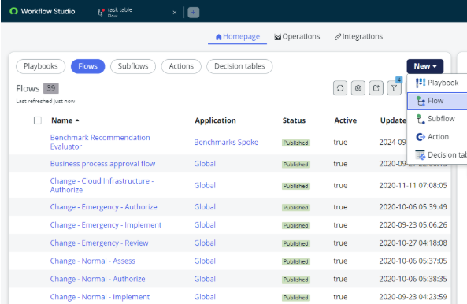

**Fig 12: Building Flow**

**Add a Trigger to the Flow**

1. In the **Flow Designer**, click **Add a Trigger**.
2. In the trigger list, search for **Create Record** and select it.
3. Set the **Table Name** to **Task Table**.
4. Define the **Conditions** as follows:
   * **Field:** Status **Operator:** is **Value:** In Progress
   * **Field:** Comments **Operator:** is **Value:** Feedback
   * **Field:** Assigned To **Operator:** is **Value:** Bob
5. Click **Done** to save the trigger.

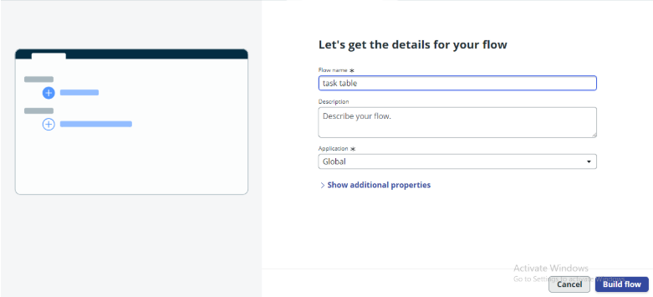

**Fig 13:Details of Flow**

**Add an Action to the Flow**

1. In **Flow Designer**, click **Add an Action**.
2. From the list of available actions, search for **Update Records** and select it.
3. In the **Record** field, drag the appropriate fields from the **Data** panel on the right (Data Pills).
4. The **Table** will be automatically populated after selecting the record.
5. Add the field **Status** and set its value to **Completed**.
6. Click **Done** to save the action.

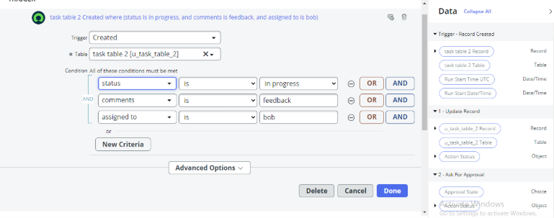

**Fig 14:Adding Actions**

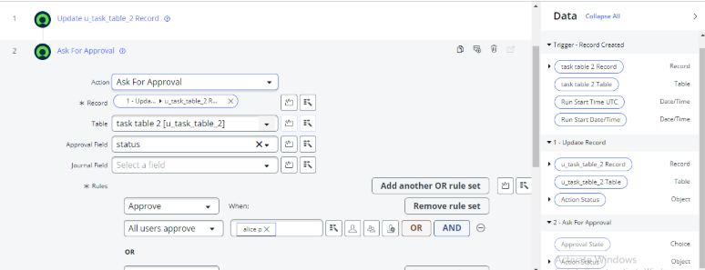

**Fig 15**

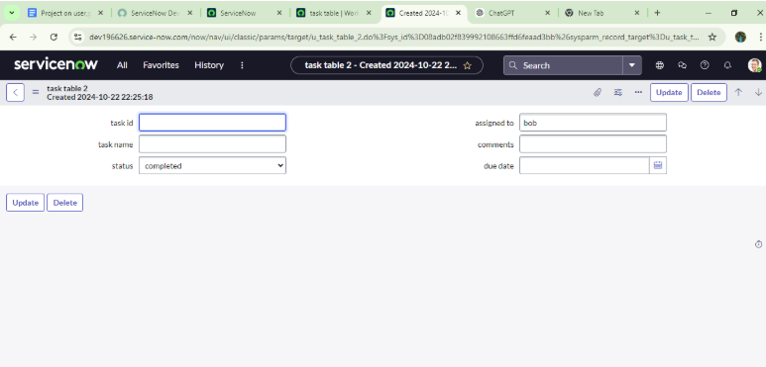

**Fig 16:Creation of task table2**

**CONCLUSION**

This scenario illustrates a structured approach to project management, clearly defining the roles of Alice and Bob within an organized workflow. With Alice providing oversight and Bob handling task execution, the team collaborates effectively to achieve project goals. The use of tables centralizes essential information, making it easy to track projects, tasks, and progress updates. Overall, this setup strengthens accountability, improves communication, and supports the successful completion of projects.